Drumnatinney, Falcarragh, Co. Donegal F92V8X5
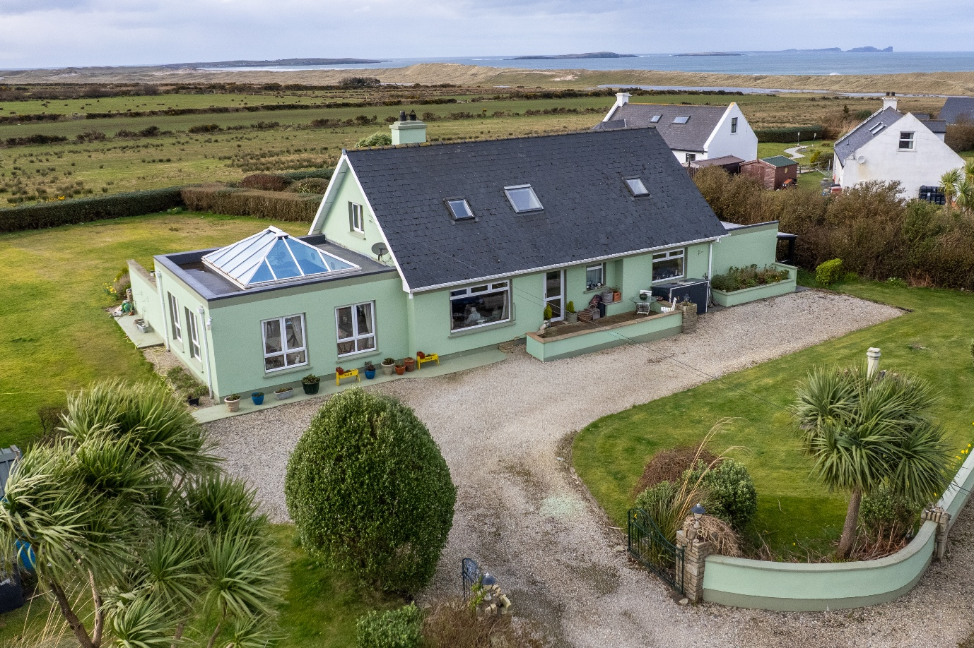
A wonderfully lovely and peaceful, easily managed and safe home, ideal for retirement, holiday, business online, family. This 3-bedroom detached residence is in a highly desirable coastal area of Drumnatinney enjoys breath taking views of both the Atlantic coastline from Tory Island to Hornhead and the surrounding mountains. Situated in a private lane just a short dander from the popular Back Strand Beach which has full parking facilities, the property offers a perfect balance of peaceful rural living and convenient access to Falcarragh village and all the local amenities.
Offers in the region of €400,000

BER Rating: C1 BER No: 119242618

Accommodation is as follows
3-bedroom – 1 ensuite-Orangery- Patio area -Conservatory – Living room – Toilet -Kitchen - Bathroom -Laundry Room – Workshop - Front Patio Area
Orangery: 5.8m x 6.4m
- This signature Ultra Frame Orangery with its glass ceiling Pilkington Actif Blue tinted self-cleaning double-glazing leads from the Living Room and then onto the Patio Outside. With lighting, power and water all on site.
- A blended in curtained Hatch with serving access to the Kitchen.
- A lovely place with its own thermostatically controlled heating system gives elegant all year-round living
Patio Area:

- The Southwest facing Patio accessed from both the Orangery and Conservatory with Mc Monagle stone paving and a side privacy wall is an all-day round area for the Sun.
- Brilliant for BBQ'S and evening parties with magnificent sunsets over the Islands and Cnoc Fola.
Living room: 4.4m x 4.4m
- Open Arched to the Hall with curtain closure, bright and cheery in the mornings and comes into its own as a Snug in the evenings with a built in multi fuel stove and matching built in TV surround.
Hall; 3.87m x 1.6m / 3.5m x 2.3m
- Under stair enclosed hot press.
- Hot water from central heating with efficient built in emersion option.
Patio to the front:
From the Front Door, this patio, similar in construction to that at the rear, East facing and often sheltered, big enough for summer breakfast for four in the Sun and for flowers to set the house off!

Kitchen: 6.0m x 3.0m
The part tiled and wooden floored Kitchen is complete with built in Freezer and American styled Samsung Fridge/Freezer for instant ice and chilled water:
Stanley oil fired range providing cooking, central heating and hot water to better any AGA: separate built in gas hob and electric oven unit and built in dishwasher:
Hatched to the Orangery and leading out to the Conservatory, the Kitchen is an unintrusive part of the action!
Conservatory: 4.5m x 4.5m
This spacious tiled conservatory from the kitchen which has French Doors to the Patio provides lovely casual eating and sitting areas taking in the views and the sunsets from the gable front.

- Double door leading to the patio
- Complete with two fans
- Tiled floor
Toilet: 2.57m x 3.0m
- Tiled floor
- Cloak room
Master Bedroom 1: 7.5m x 4
Spacious enough for an office desk!
Ensuite: 1.38m x 2.3m
- Fully tiled both walls and floors
- Walk in power shower unit.

The downstairs alone provides all the needs for a retired couple or a couple working from home.

Upstairs
Bathroom: 3.2m x 1.36m
- Bath separate
- Power shower
- Views over the Island

Bedroom 2: 5.18m x 4.31m
- Walkin wardrobe
- Storage in the eaves
- Wooden floor
Landing area: 4.13m x 2.0m
- Great for an office desk with perfect Internet connections and overlooking the front garden
Bedroom 3: 4.0m x 5.0m
- Wooden flooring
- Views stretching to tory island
Upstairs is comfortable and complete for family or friends with fabulous views.
Laundry Room: 2.0m x 3.6m
- Plenty power points
- Fully set up for washing,tumble drying, ironing and music complete with walls for pictures!

Workshop: 4.5m x 3.6m
Complete with work bench, power points and storage facilities. Secure
Covered roof fuel storage area
Discreetly placed on the house gable
With space for a year’s supply

Property Features:
- 3 minutes from Falcarragh Town centre
- Great privacy - off the road 50 yards down a secluded lane
- Wonderful peaceful setting to enjoy the Donegal experience
- Stunning coastal location
- Short distance to the back strand beach
- Beautiful coastal and mountain views
- Generous site with a private outdoor space
- Bright and spacious 3-bedroom detached residence
- Ideal family home, holiday retreat or investment property
- Beautifully designed orangery extension

Please Note:
This property is owner-occupied, and we kindly request that all visitors respect the owners’ privacy at all times.
Viewings are strictly by appointment only. We look forward to welcoming prospective purchasers to experience the charm and relaxed ambience of this home.

.

Orangery
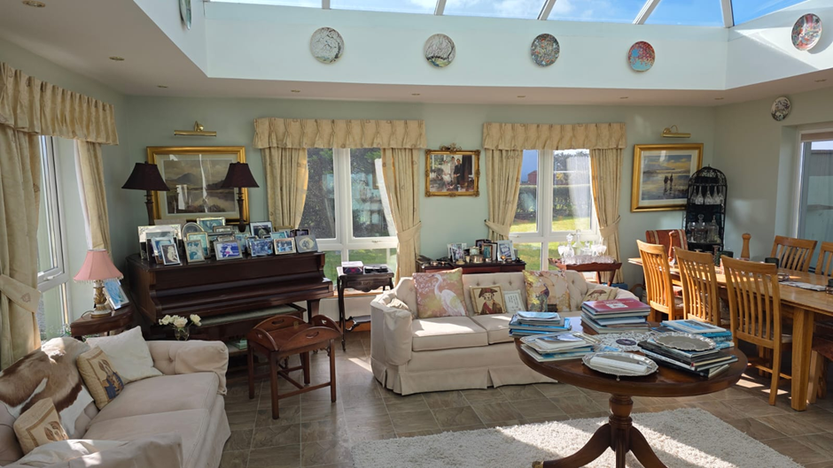

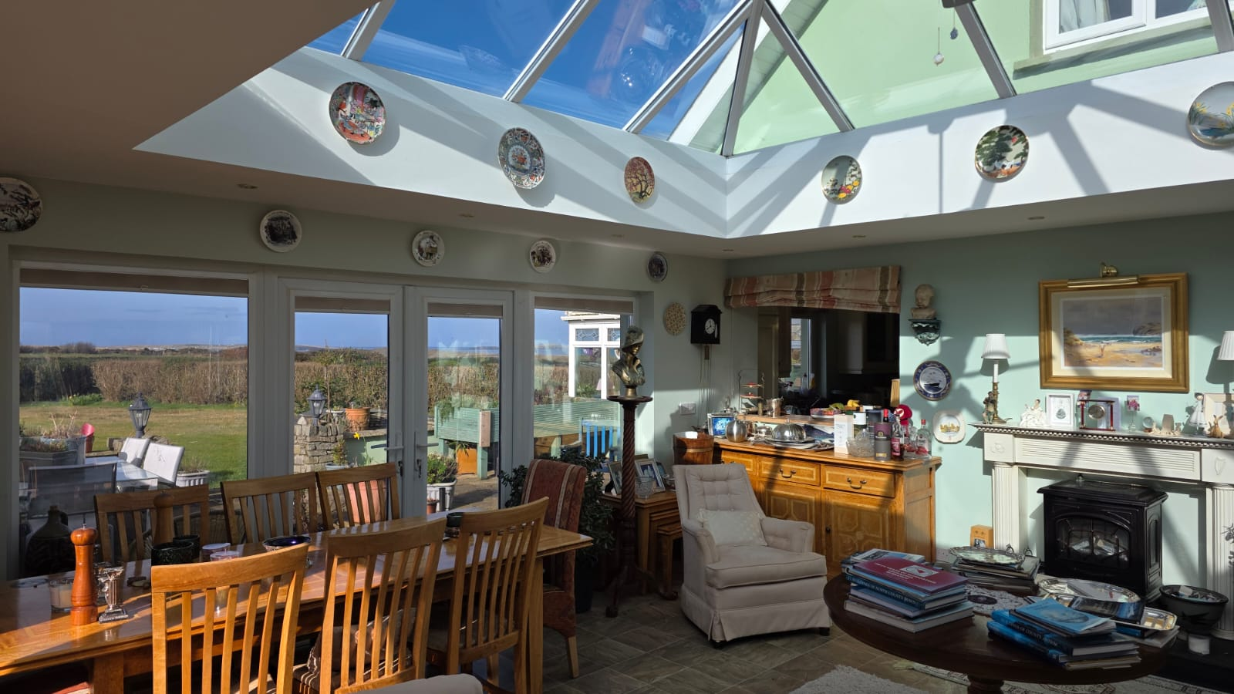

Hallway
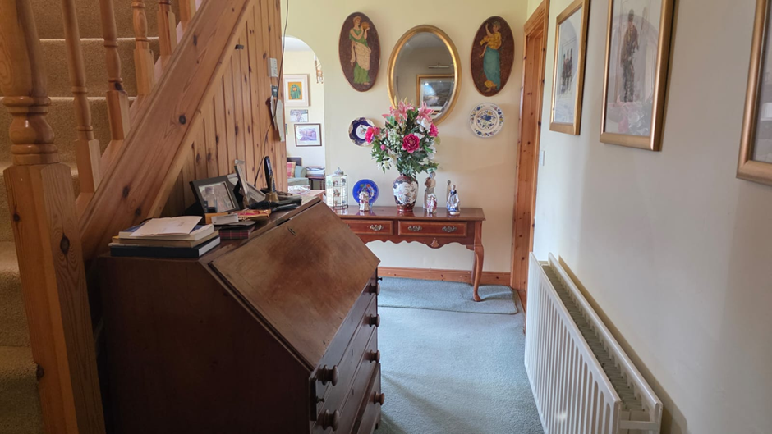

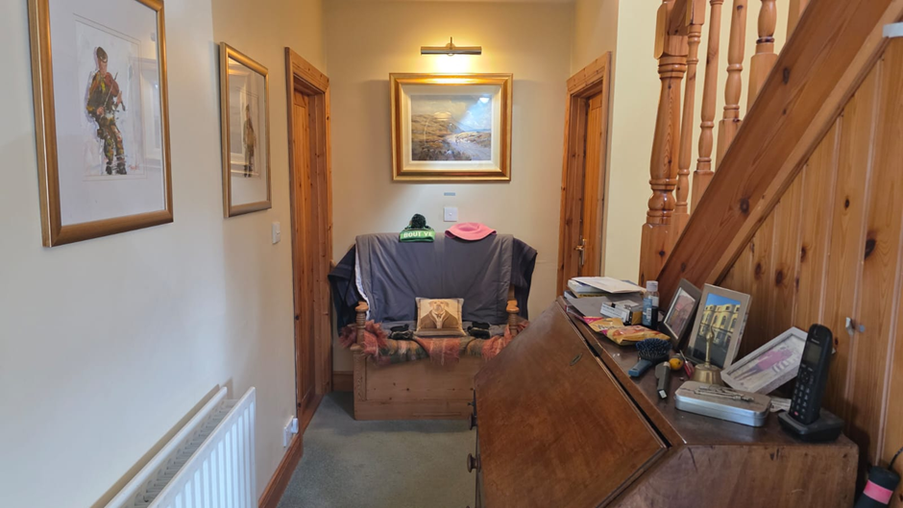

Kitchen
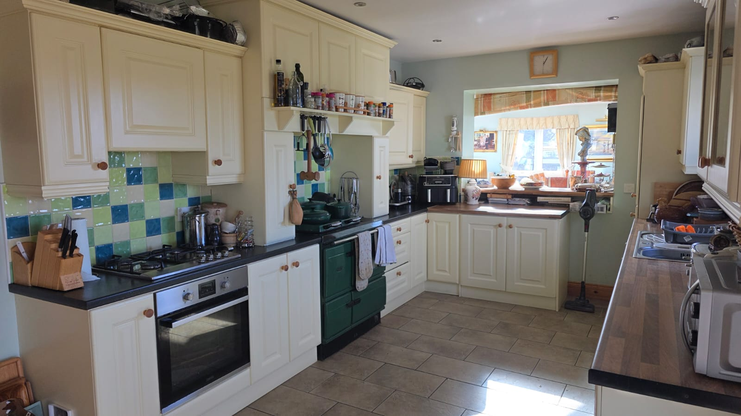
Conservatory area
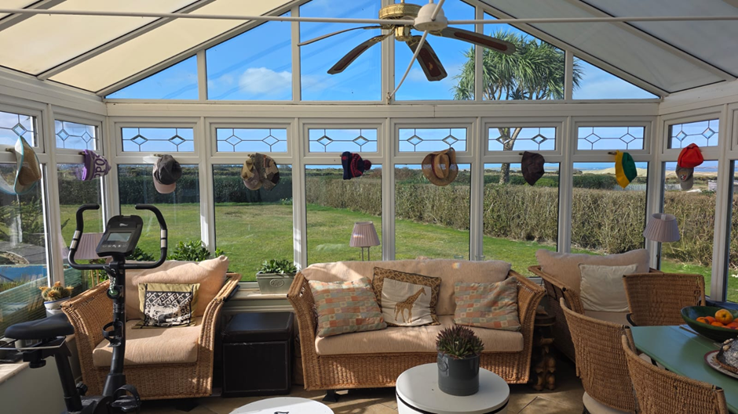

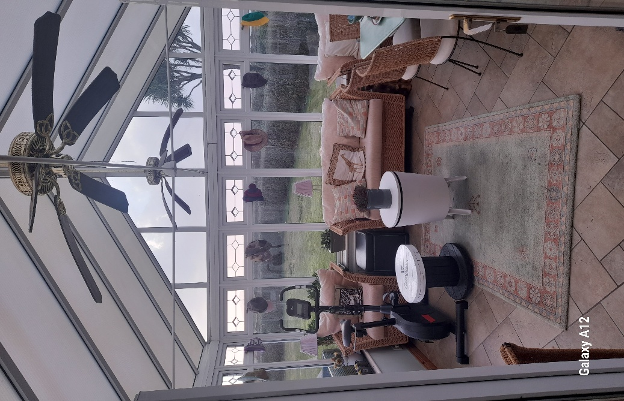
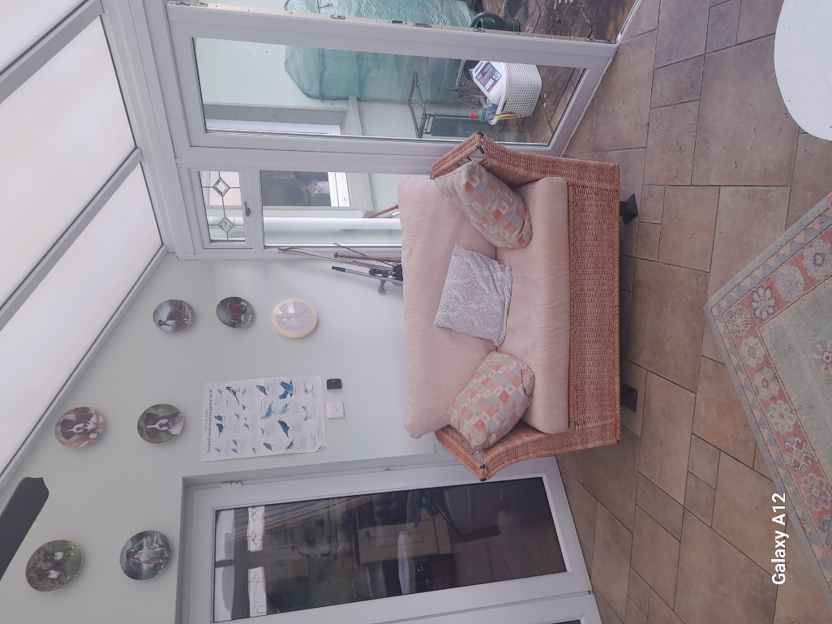

Living Room
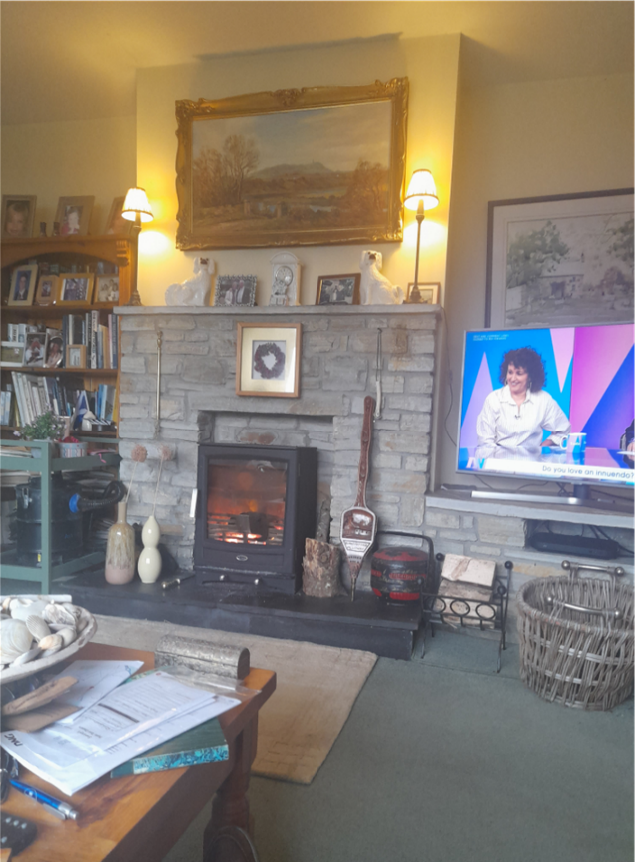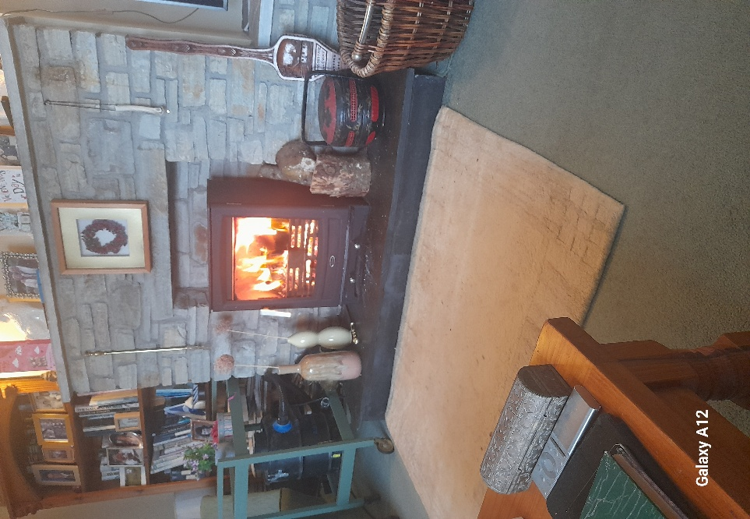

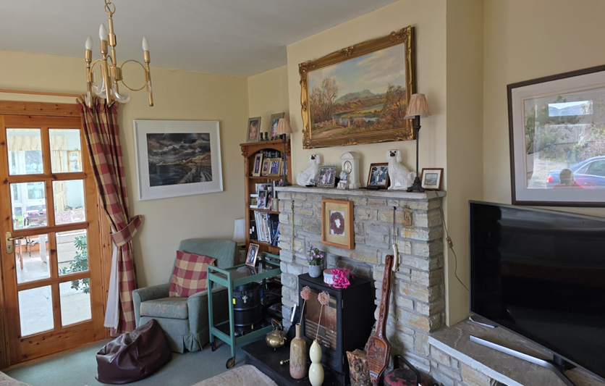
Bedroom
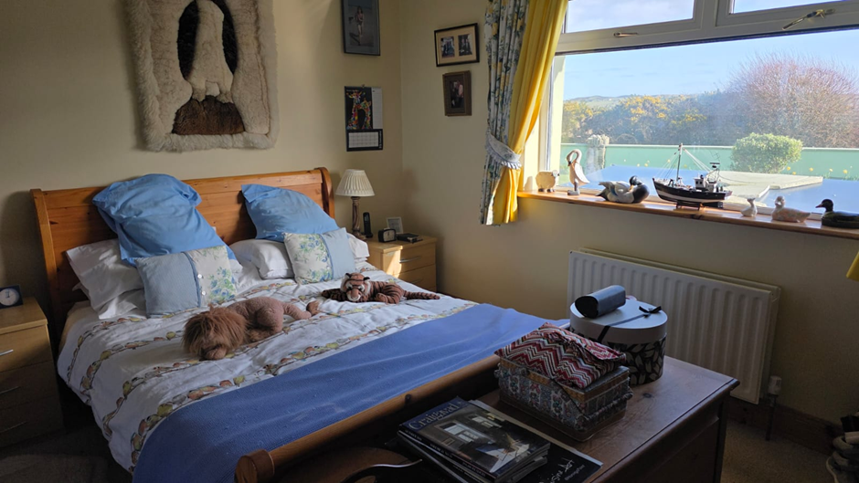

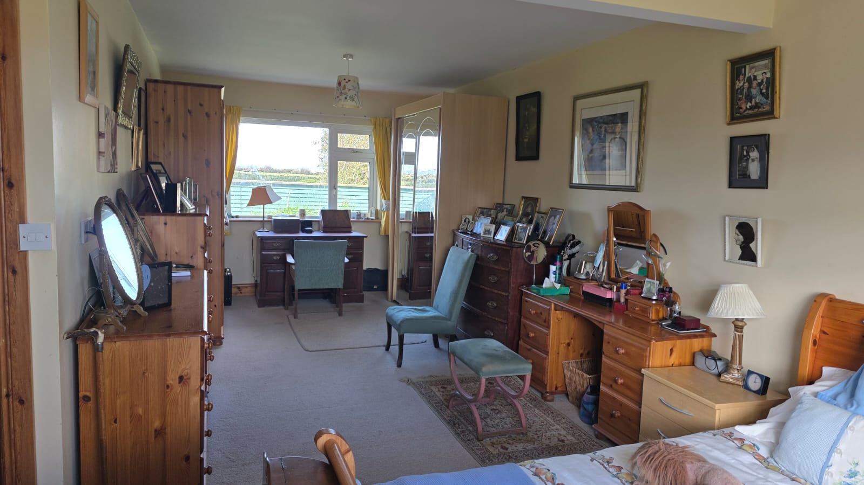
Bathroom
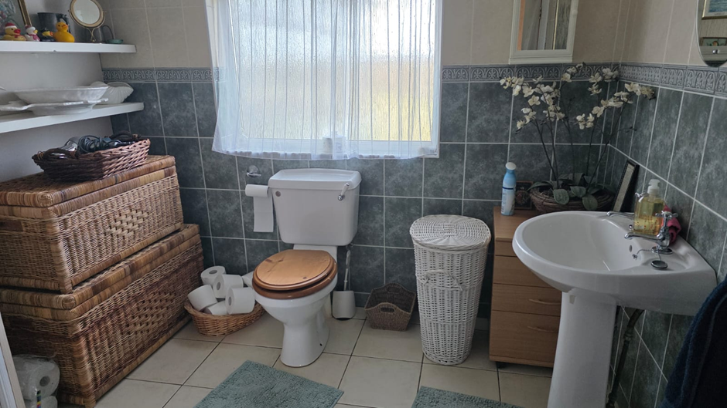

Bedroom upstairs
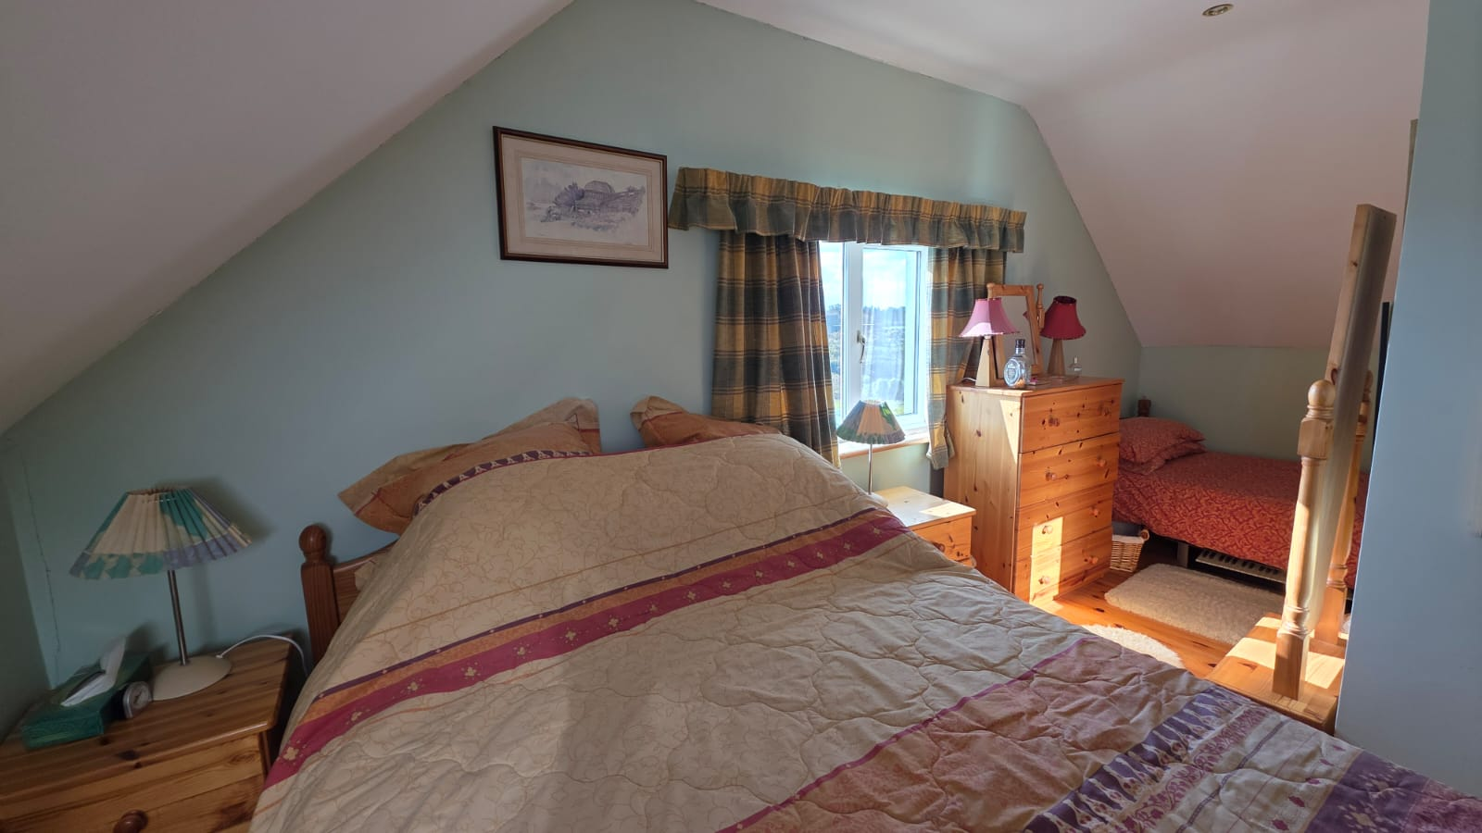

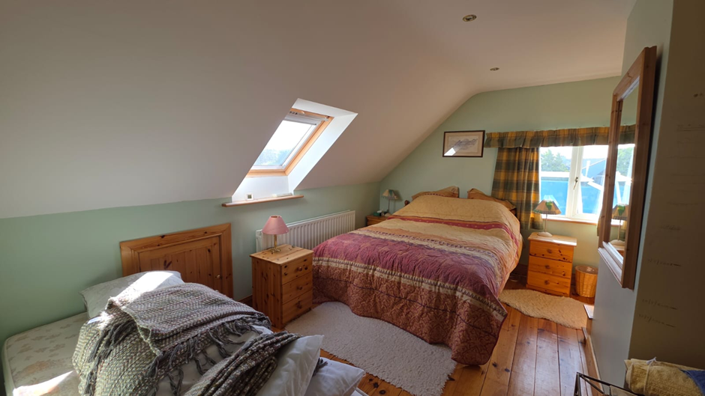

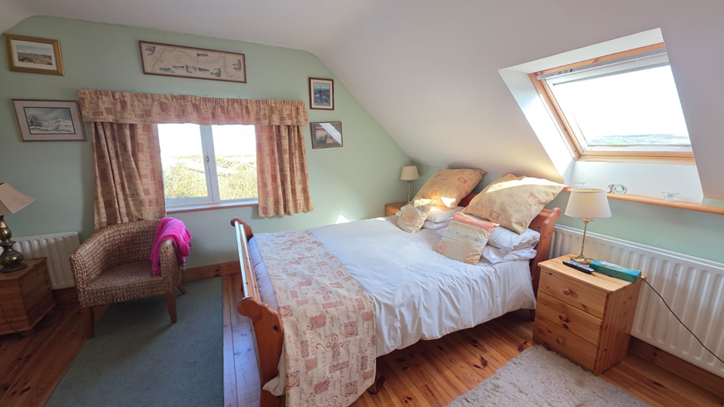

Bathroom Upstairs
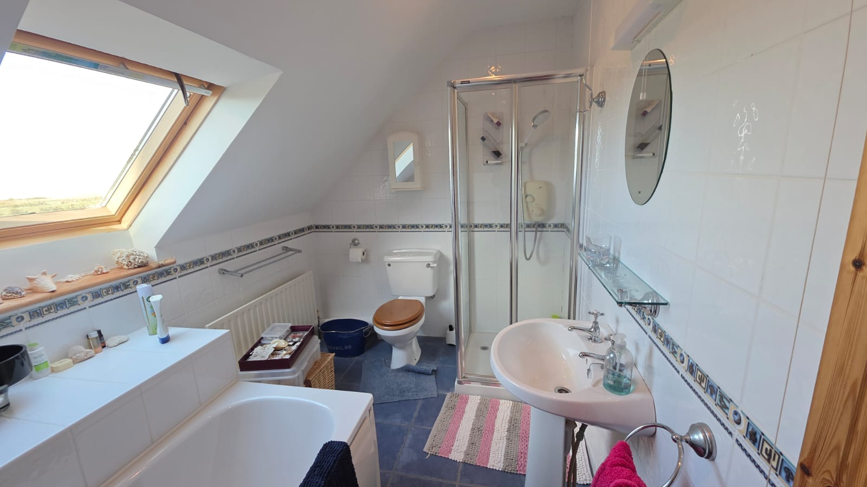

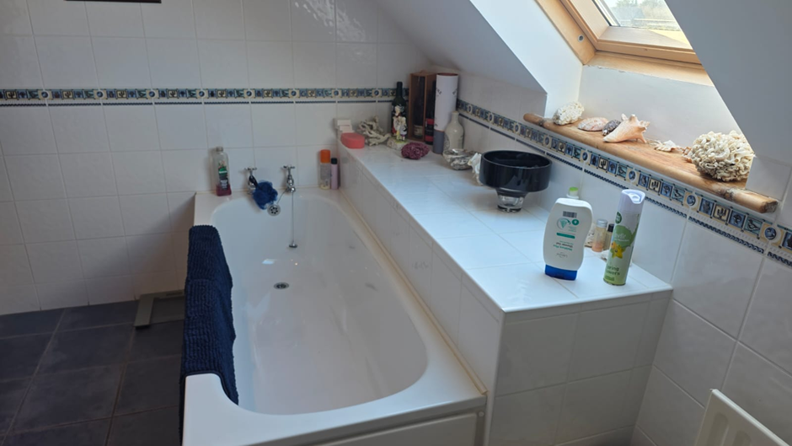

Laundry Room
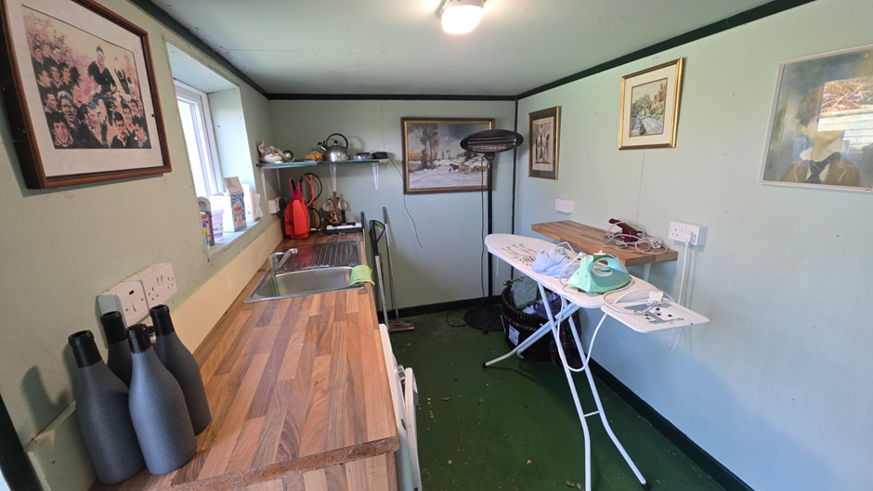

Views from the upstairs
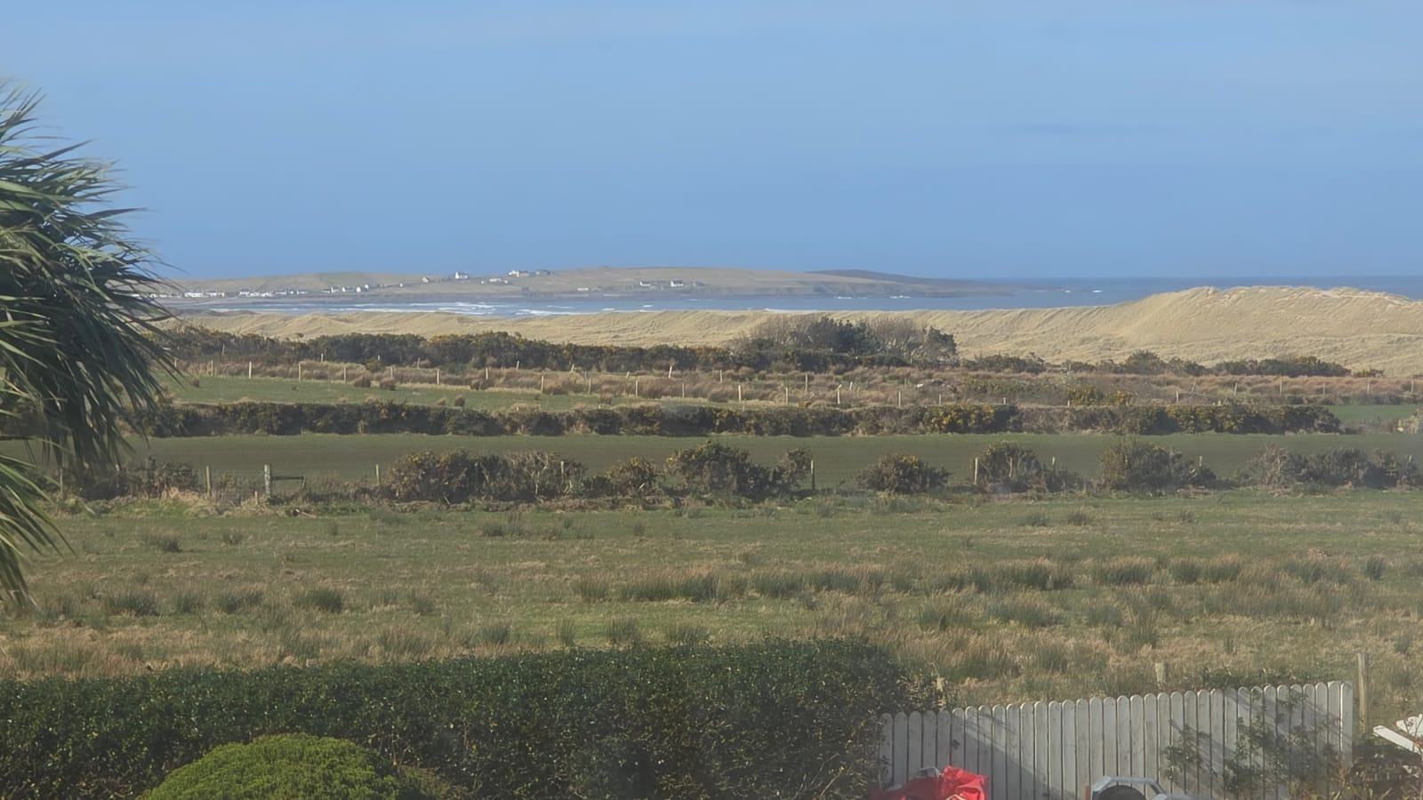

Raised herb bed
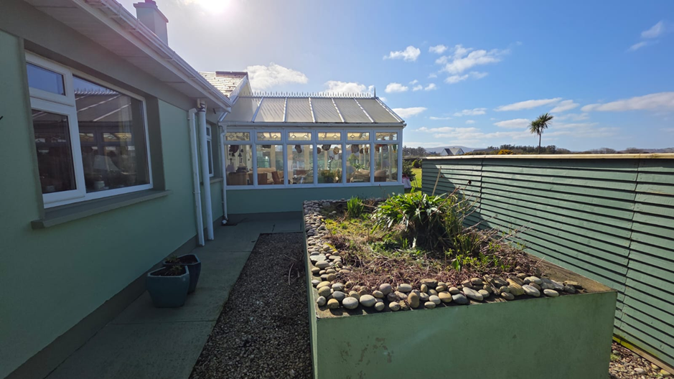
Rear view of the property with large garden
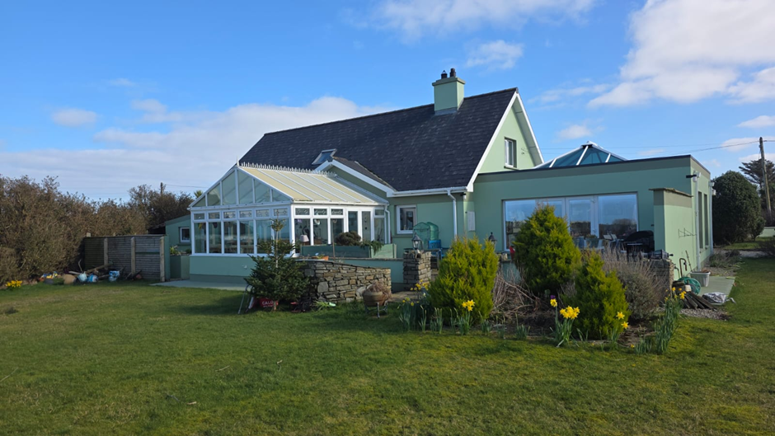

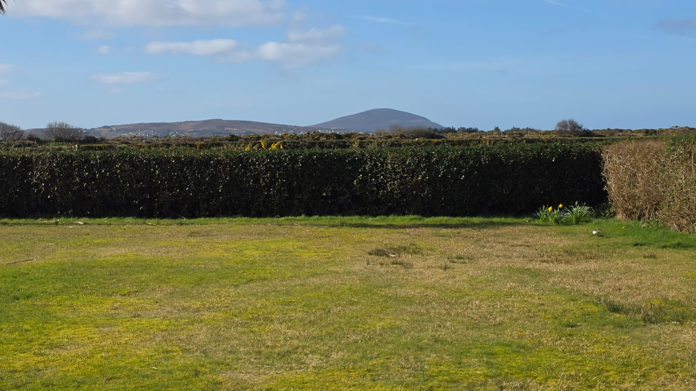

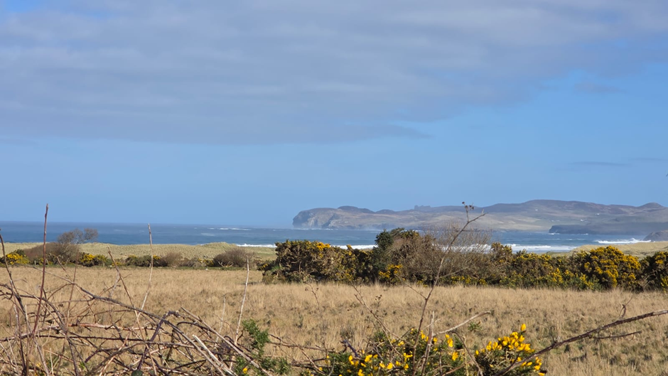

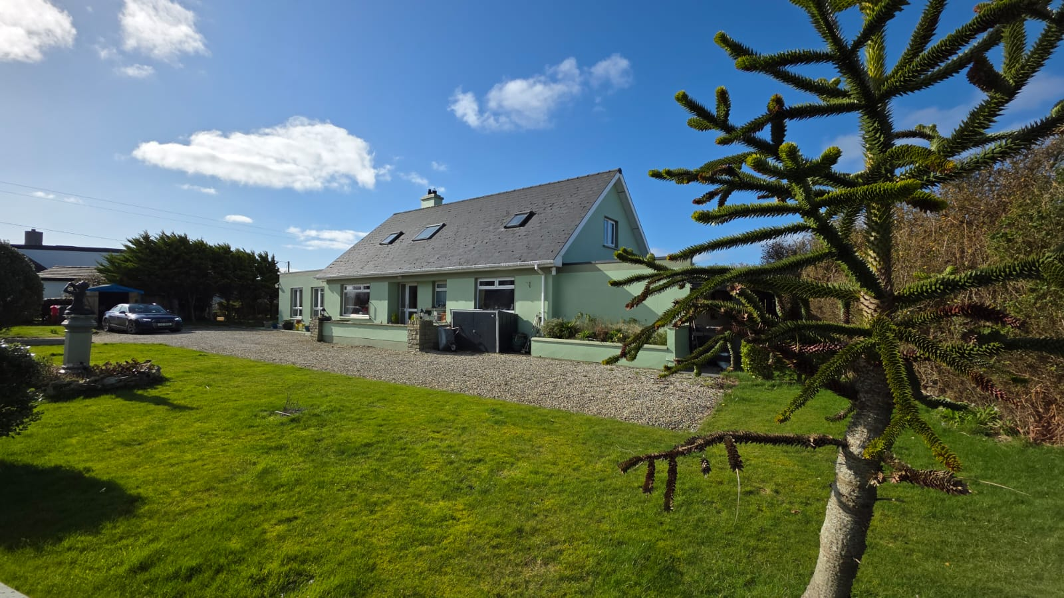

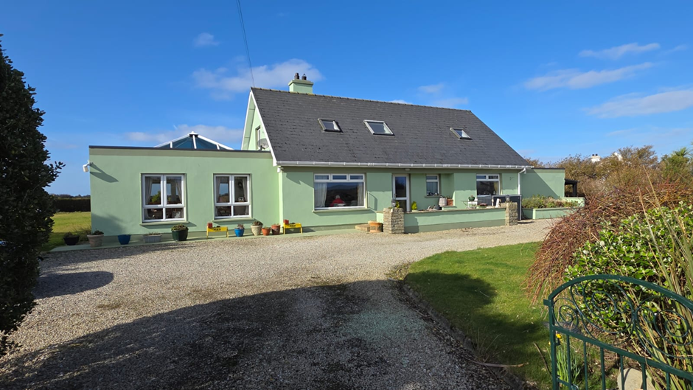

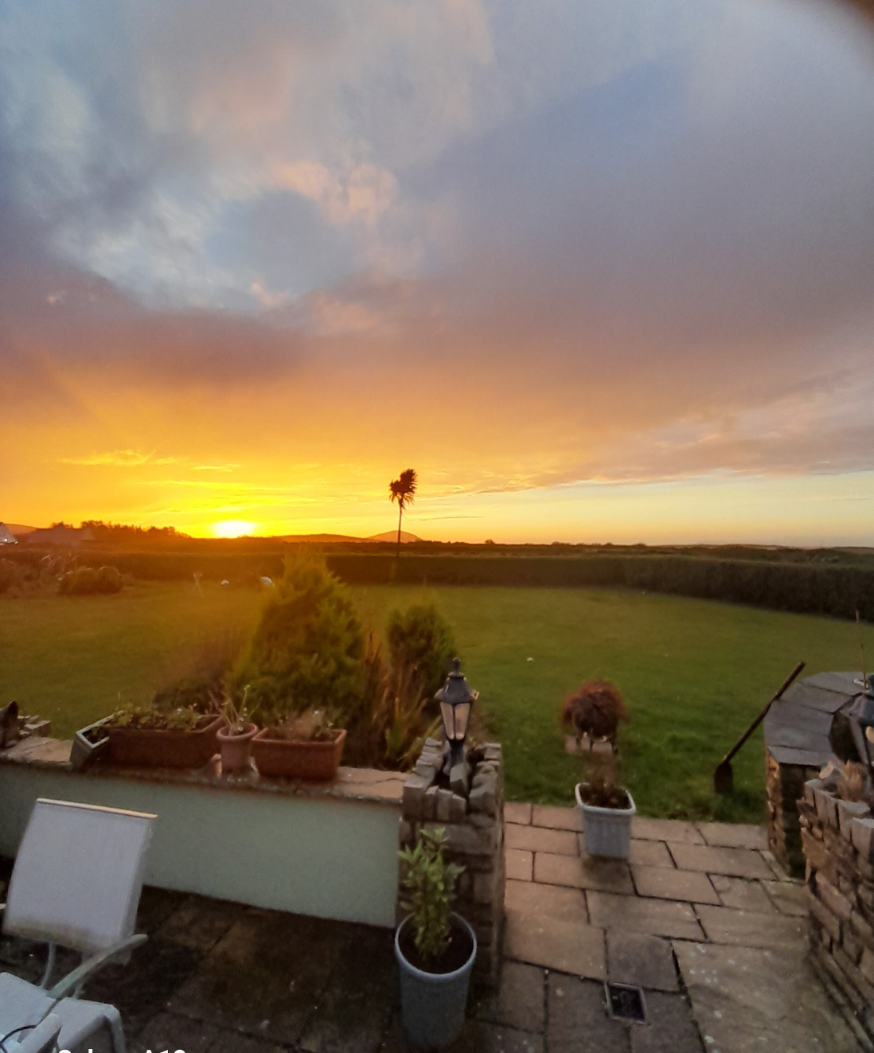

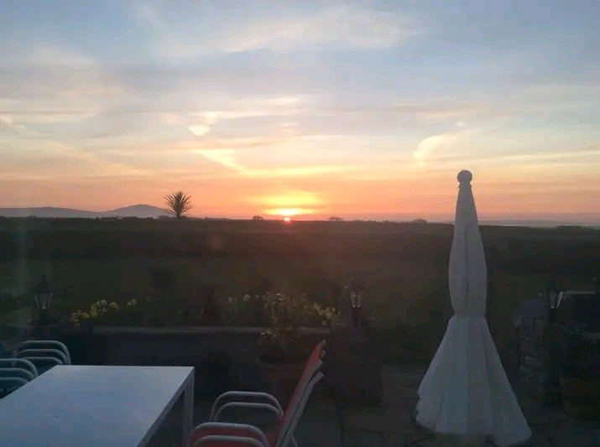
Drone pictures of the property
